Situation: The Security Operations Center (SOC) has indicated some suspicious behavior on an endpoint and have sent you the Windows Security and PowerShell event logs to identify the Indicators of Compromise and any additional information. The two files are CTF_Security.evtx & CTF_Windows PowerShell.evtx.

Please determine the following:

What IP address is contained within the malicious PowerShell Script?

Flag: 172.16.28.5

What User account was able to log into the system from the system identified in the PowerShell script?

Flag: JAdams

Detailed Answers:

1. Open the CTF_Windows PowerShell.evtx file in any Event Log analysis tool (in this case, the tool Event Log Explorer is used. This is a tool that can be downloaded by the participants for free).
2. There are a large number of entries that contain the entire PowerShell script:

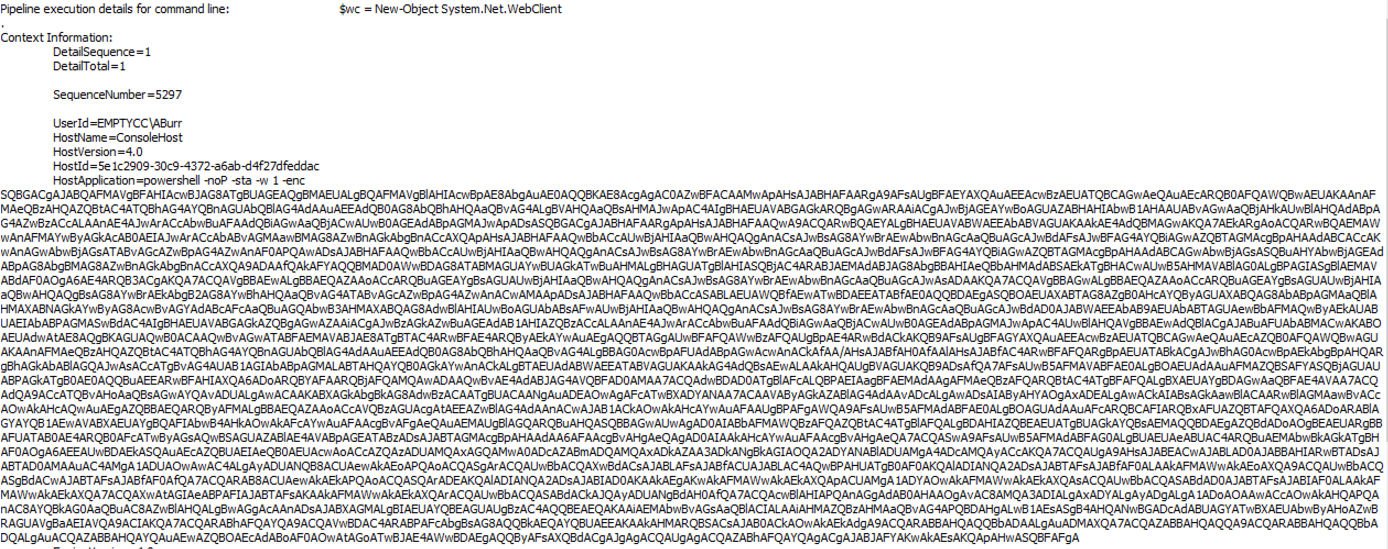

3. Extract the Base64 characters and use either the Linux Decode CLI commands or a tool such as Cyber Chef to decode the text.

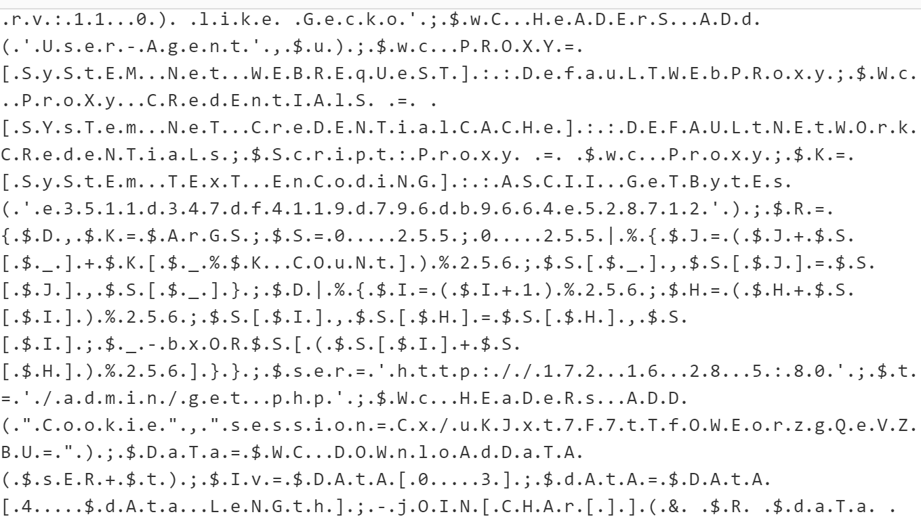

For the second question:

1. Open the CTF_Security.evtx file
2. Determine successful logons via Windows Event Log ID 4624 and look for Type 10 (Interactive Logon) or search for the IP address 172.16.28.5

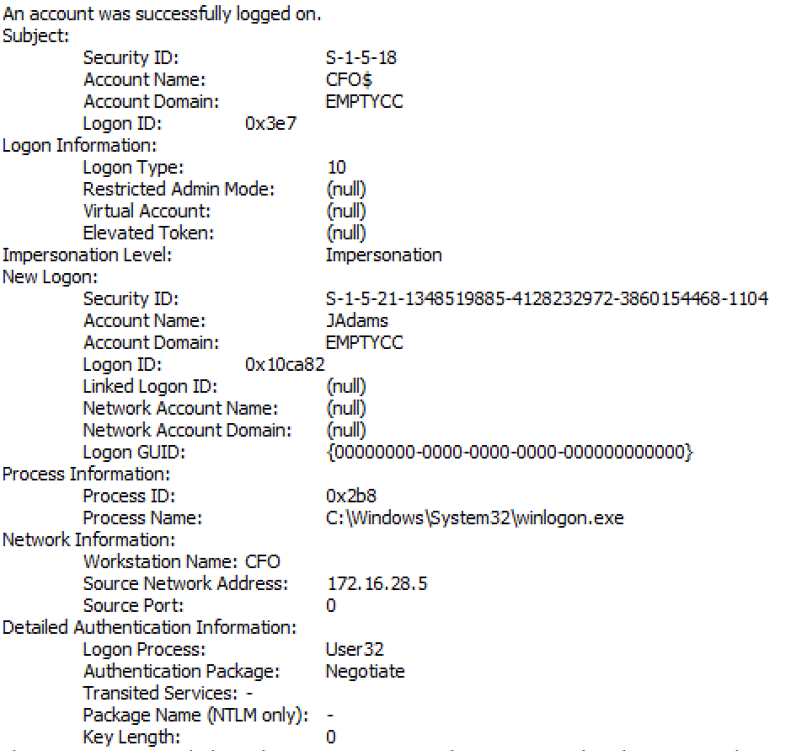

The SOC has also forward potential malware sample to you for evaluation. They have sent you a 7Zip folder with the file name CTF_Spokane2022.7z with the password “infected”. The SOC manager is requesting the following information concerning the payload

What is the SHA-256 Value of the Payload?:

Flag: 6881531ab756d62bdb0c3279040a5cbe92f9adfeccb201cca85b7d3cff7158d3

What IP address does the script establish a connection with?:

Flag: 47.242.164.33

What has Microsoft identified this file as?:

Flag: TrojanDropper:PowerShell/Cobacis.B

What tool produced this script?:

Flag: Cobalt Strike

Solution:

Hashcalc or similar hashing tool for the PowerShell Script

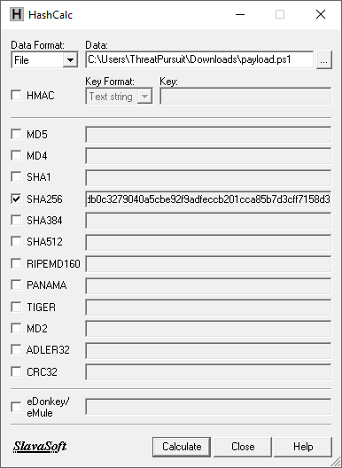

Open the file payload.ps1 via a text editor [Do not open as a PowerShell Script!!!]

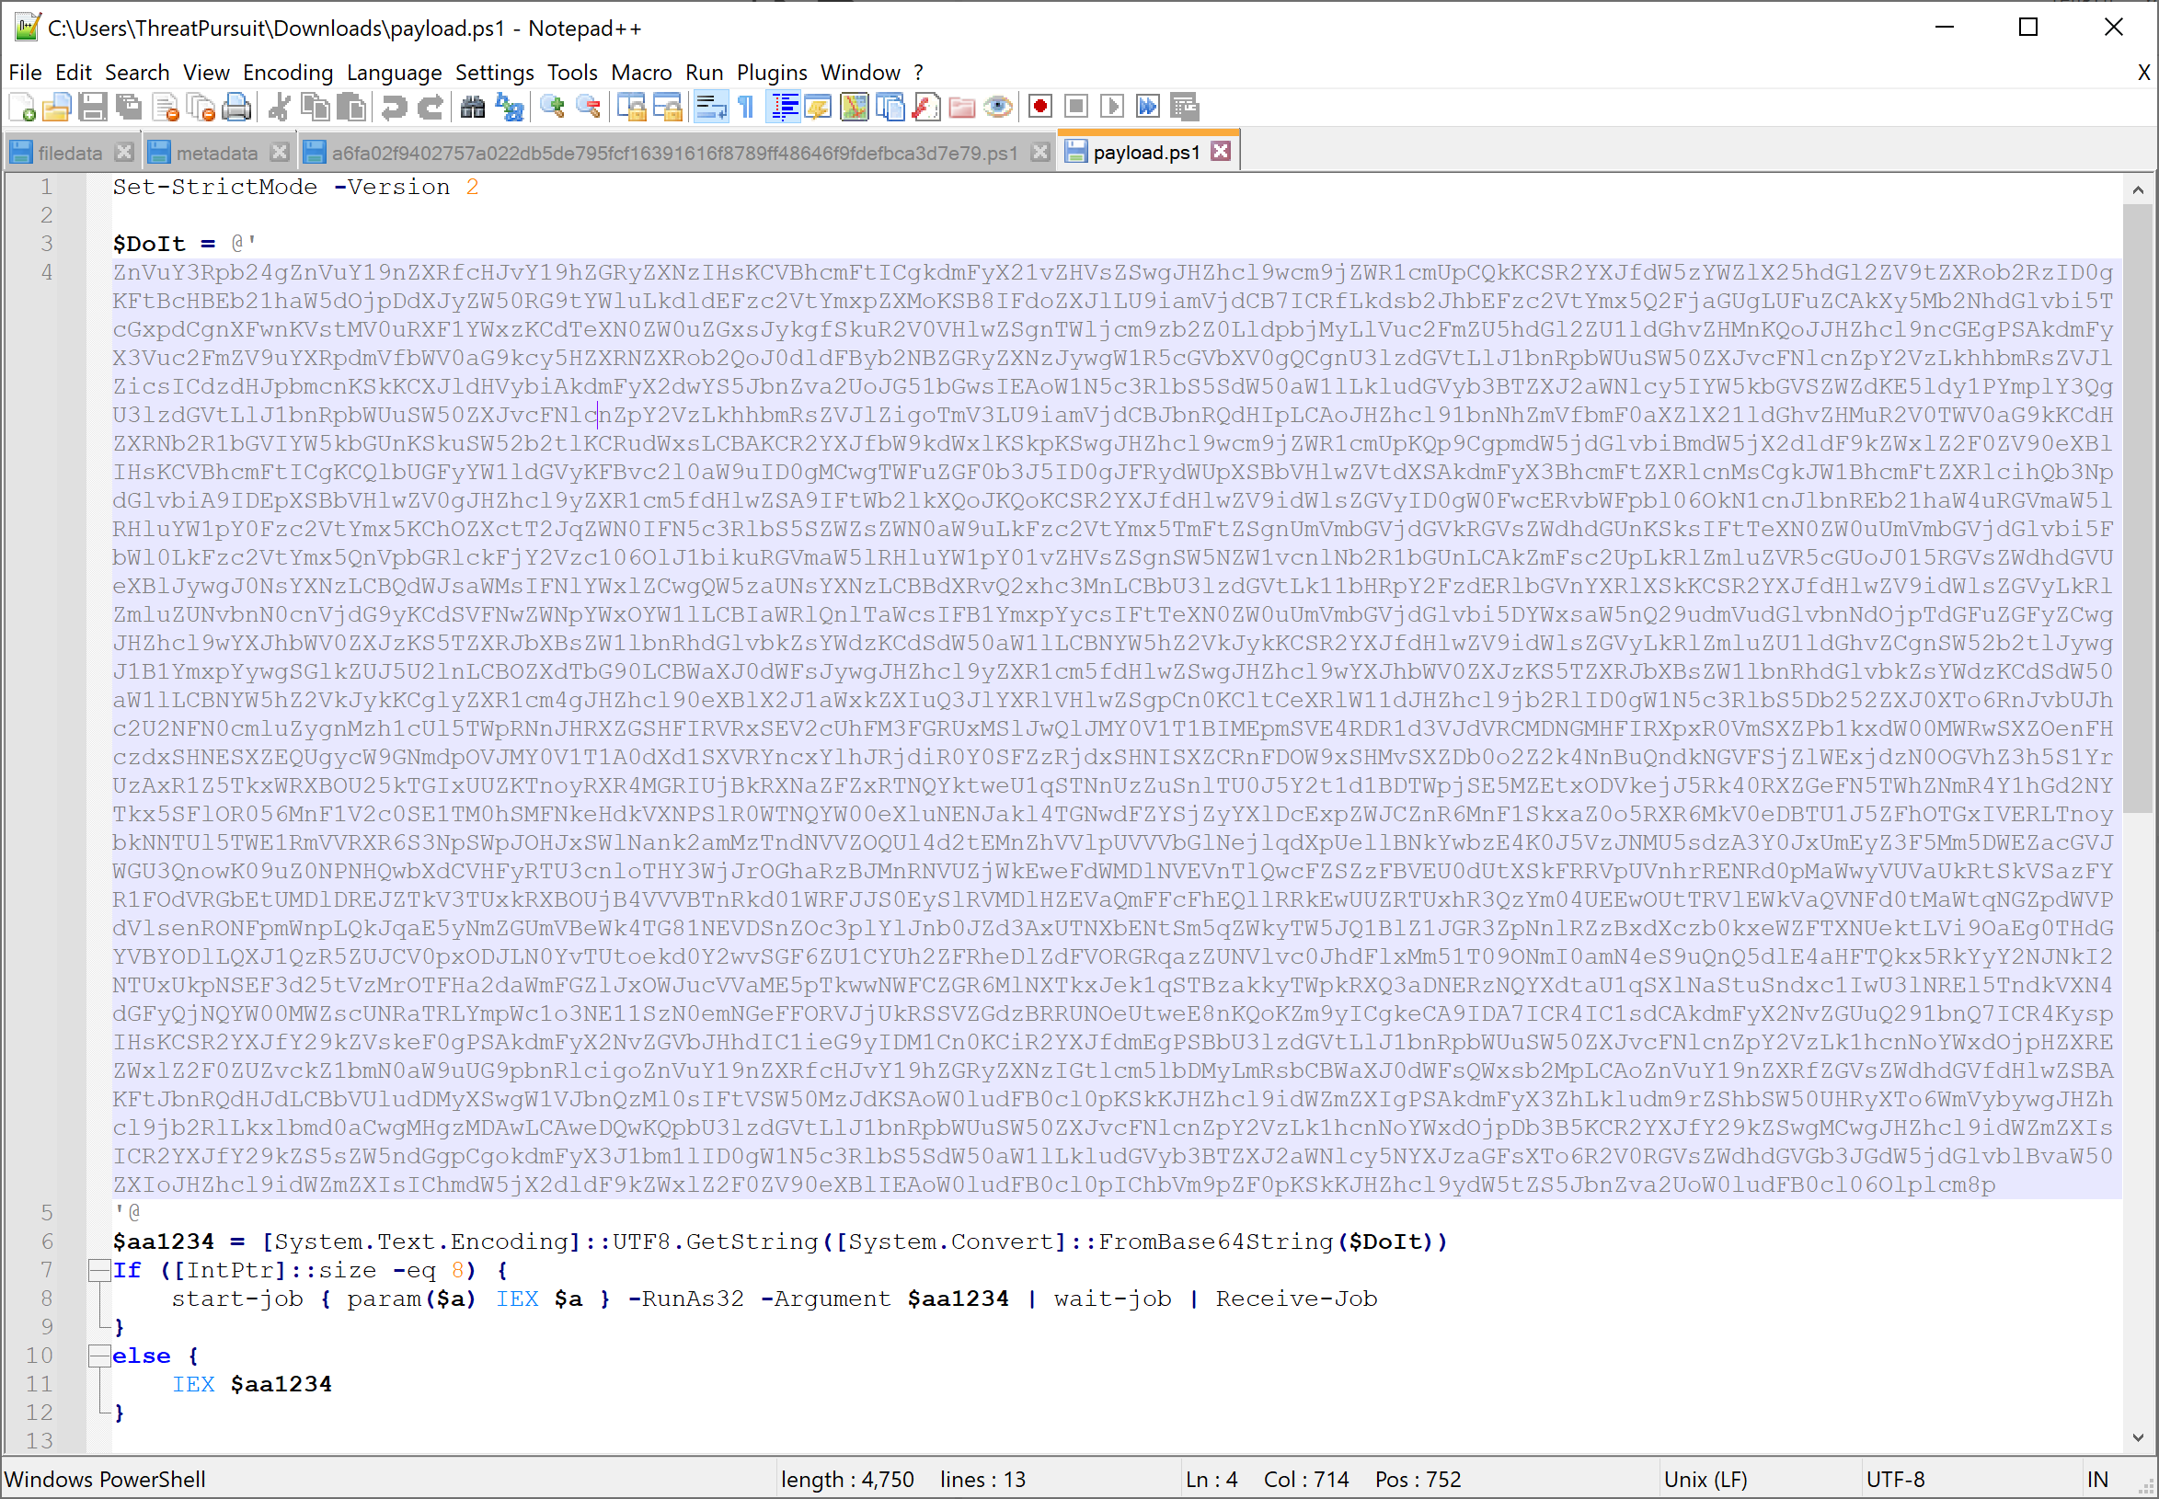

Take the Base64 encoded material and decode. If there is a sticky point, have them use Cyber Chef and decode that way.

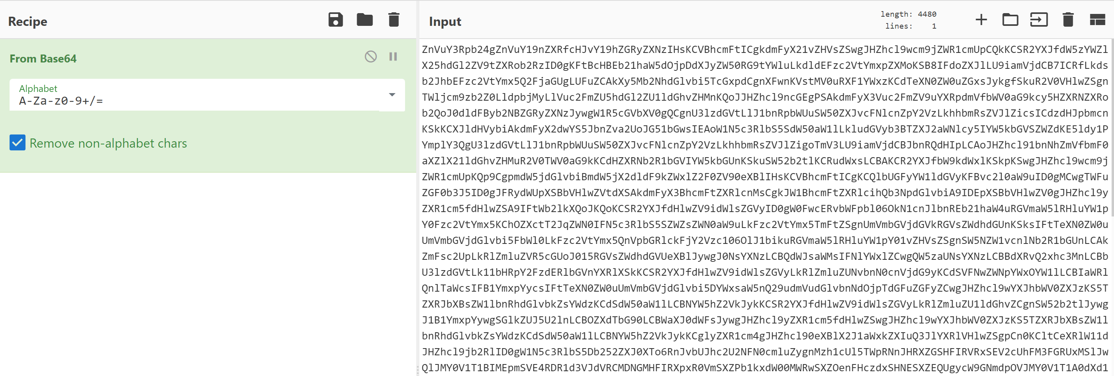

This produced a decoded output that also has another Base64 encoded portion. This is a very common obfuscation tactic used by threat actors in scripting their initial foothold or executing tasks on remote systems.

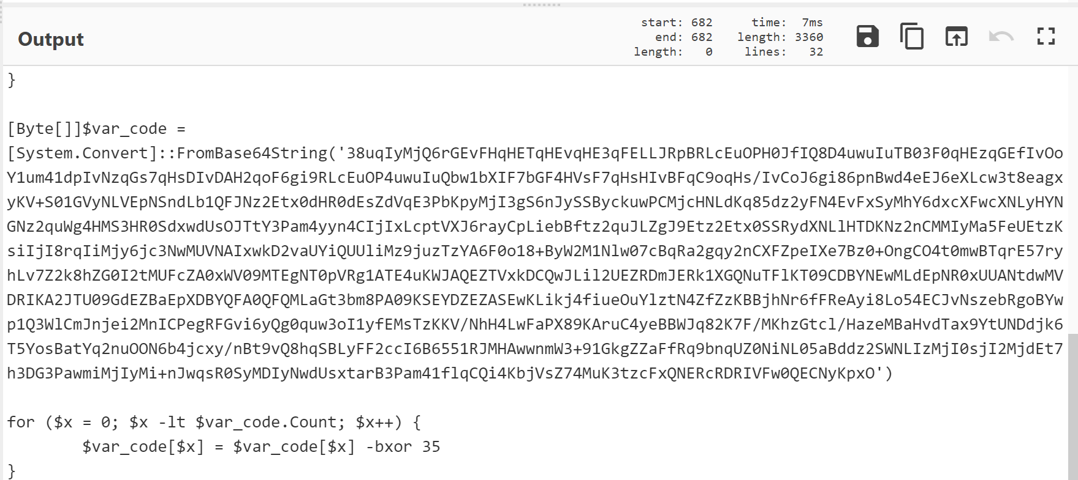

They will need to extract the additional Base64 encoded text and repeat the process with one caveat: there is an XOR function that needs to be addressed.
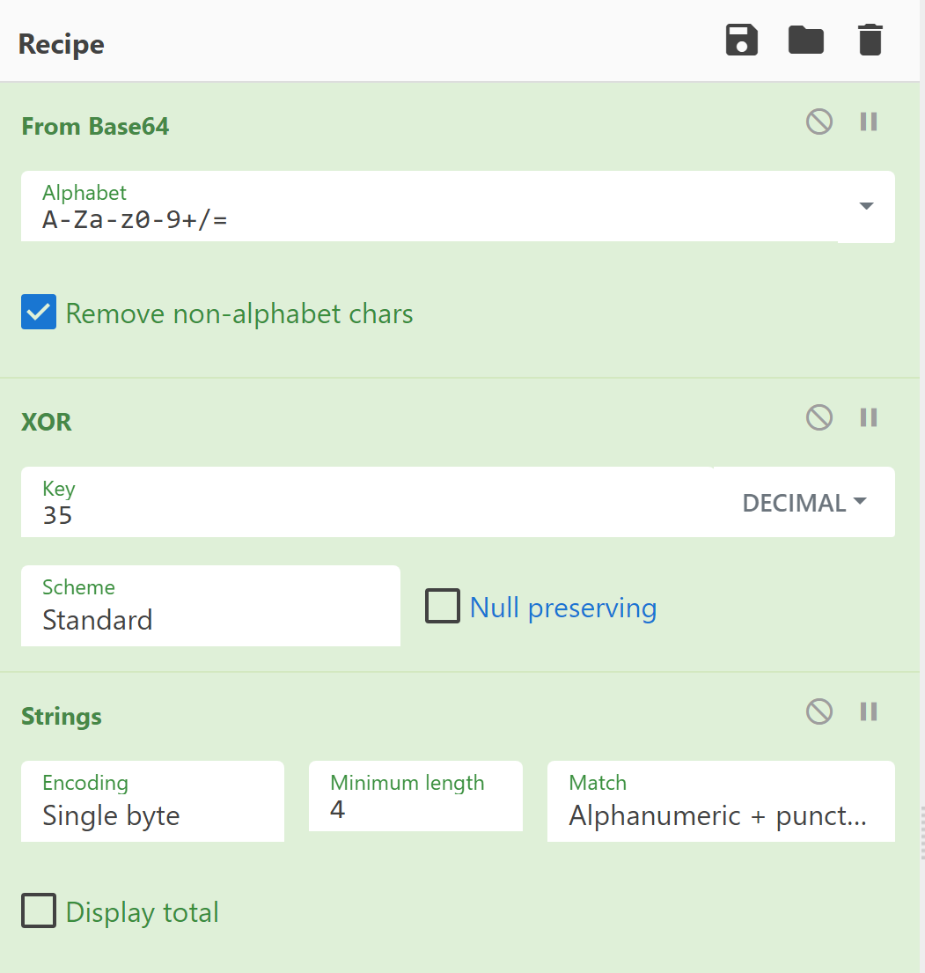

Finally, adding the Strings output produces the following:

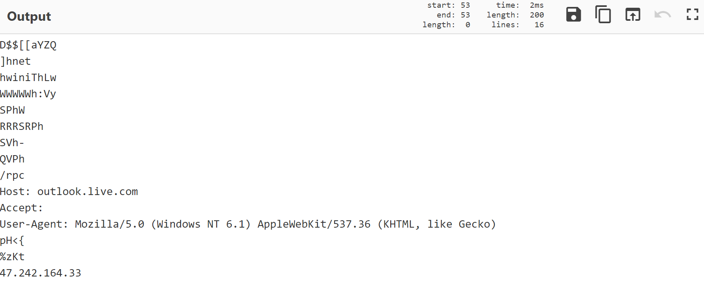
A check of VirusTotal provide the following information:

The hash returns the following from Microsoft:

The community info indicates:

